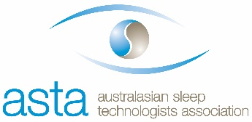
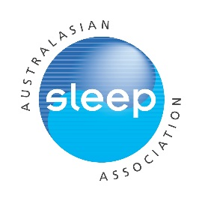
Rob Pierce Grant in Aid
Applicant name:
Contact Details: Email: Phone:
Current institution:
Title of proposed project:

Note: All applications must be completed using this template within the allocated page limits (Times New Roman, 12pt font, single-spaced)
Submission instructions:
In addition to this completed application form, please convert into a pdf and attach a copy of your CV and a completed and signed proof of early career status form and email as a single pdf with the following title “2020 Rob Pierce Grant in Aid Application” to Mischka Yates communications@sleep.org.au by midnight (AEST) Friday July 31st 2020.

Further details for what to include in your CV (as appropriate):
-Name and contact details
-ASA membership number or evidence of ASTA membership and year of initial membership
-Education/training (including year of completion of postgraduate degree or equivalent)
-Appointments/positions: present and past
-Awards and honours
-Previous grants
-Brief summary of research: current and completed
-Publications and presentations

Applications will be judged on:
1) Scientific merit (1/3)
2) Significance (1/3)
3) Track record relative to opportunity (1/3)
Length of ASA /ASTA membership may also be taken into consideration.

Only full applications with all requested materials submitted prior to the closing date will be considered.

Brief description of the project for which the funds will be used
(up to 1.5 pages max using headings below as appropriate + up to 1/2 page of references):
Background:

Aims and hypotheses:

Research plan (briefly describe study design, key proposed methodology and outcomes):

Brief description of the project for which the funds will be used (continued)
Research plan (continued):

References (1/2 page max):

Brief budget with justification including description of how funds will be used (include other sources of funding support if applicable) (1/2 page max):

