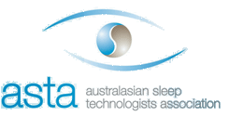
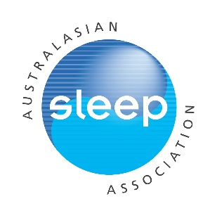
Helen Bearpark Scholarship
Applicant name:
Contact Details: Email:
Phone:
Current institution:
Proposed overseas host institution:
Title of proposed project:
Field of study (e.g. paediatrics, circadian, insomnia, sleep apnoea etc.):
Note: all applications must be completed using this template within the allocated page limits (Times New Roman, 12pt font, single-spaced)
Submission instructions:
In addition to this completed application form, please convert to a pdf and attach a copy of your CV and a brief letter of acceptance from your proposed supervisor/host and email as a single pdf with the following title “2020 Helen Bearpark Scholarship Application” to Mischka Yates communications@sleep.org.au by midnight Friday 31st July 2020.
Further details for what to include in your CV (as appropriate):
-Name and contact details
-ASA membership number or evidence of ASTA membership and year of initial membership
-Education/training
-Appointments/positions: present and past
-Awards and honours
-Previous grants
-Brief summary of research: current and completed
-Publications and presentations

Further details of what to include in letter of acceptance (as appropriate):
-statement of intent to fully supervise the applicant
-reality of anticipated outcome and timetable
-availability of resources
-evidence of recent research achievements within sponsoring/host department
Applications will be judged on:
-Quality of proposed work (30%)
-Track record and potential of applicant relative to opportunity (30%)
-Quality of sponsoring institution (20%)
-Likelihood of enduring exchange and benefit to sleep research/sleep medicine (20%)
-Length of ASA/ASTA membership may be taken into consideration.

Only full applications with all requested materials submitted prior to the closing date will be considered.

Brief description of the project for which the funds will be used
(up to 1 page description + up to 1 page of references):

References (1 page max):

Brief overview of host institution (1/2 page max):

Brief description of how this travel will benefit the applicant’s career in sleep research/ medicine &/or the applicant’s institution, & sleep community in general (1/2 page max):

Timetable-specify proposed departure date, commencement date, expected duration of scholarship & hours per/week if not full-time (1/2 page max):

Brief budget with justification including description of how funds will be used (include other sources of funding support if applicable) (1/2 page max):

