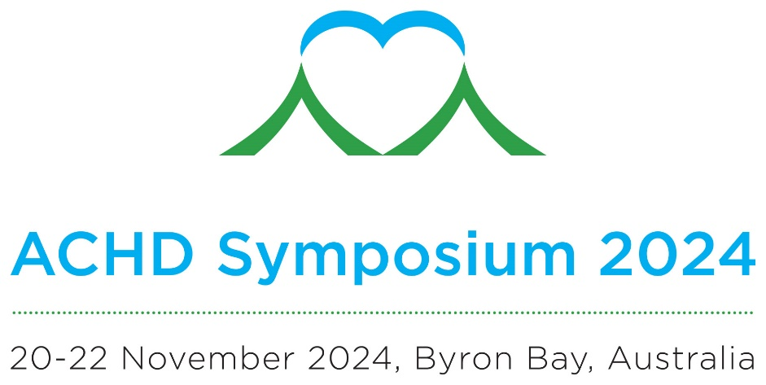

Fellows in training, Early career ACHD clinicians, Nursing and Allied Health Session Submission

Clinical Dilemmas and Interventional/Surgical Challenges

To submit a proposal for a ten-minute presentation during this session please complete the form below and return to achd@theconferencecompany.com by Thursday 1 August 2024

Name
Professional Group
Institution
Presentation Title
Topic Description
(up to 250 words)

