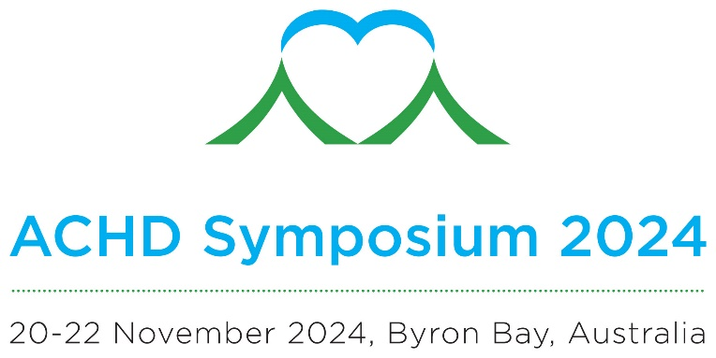

CALL FOR ABSTRACTS

You are invited to submit an abstract for the Adult Congenital Heart Symposium 2024.

Original Abstracts are invited on the theme of adult congenital heart disease for
poster presentations.

The closing date for submissions is 1 August 2024.

IMPORTANT DATES
- Call for Abstracts Open: 15 March 2024
- Closing Date for Submission of Abstracts: 1 August 2024
- Approximate date of notice acceptance of abstract: 30 August 2024

Please note all abstracts must be submitted in accordance with the guidelines below:
- All abstracts must be original work. An abstract should not be submitted if the work has been published/accepted for publication or presented at a national meeting or World Congress held in New Zealand or Australia, prior to the abstract submission deadline.
- An abstract must contain sufficient information so that if published it will be a complete report independent of presentation. The text should not contain statements alluding to results or conclusions not presented within the text.
- There is no limit to the number of abstracts that may be submitted by an individual. However, splitting of a body of work into multiple abstracts is discouraged and consolidation into one abstract is preferred.
- Submission acknowledges consent to publication of the abstract in the ACHD 2024 Symposium handbook.
- The presenting author will be required to register for the Symposium in order to ensure their abstract(s) is included in the final program. Deadline for presenting author registration will be advised in the acceptance letter.
- All submissions must be submitted to the Symposium Managers at achd@theconferencecompany.com by the deadline. Any late or incomplete submissions will not be accepted or considered for review.
- All abstracts must be prepared according to the guidelines provided. Abstracts will only be accepted and published if submitted using the supplied template.
- The abstract must not exceed the 250 word limit. Abstracts exceeding the 250 limit will be returned for re-submission. The word limit relates to the text only of the abstract and does not include title.
- The abstract should be typed in Arial font, size 11pt and single line spacing.
- Use the approved abstract template.
- Paragraphs must be separated by an empty line and must be left justified. Do not indent the first line of a paragraph.
- Tables and figures can be included but the abstract must be laid out as specified and must not exceed one page.
- Please only use standard abbreviations or define them in full.
- Accuracy is the responsibility of the author - please ensure you proofread your document carefully.
- DO NOT include authors and affiliations in the abstract, as these will be entered into the online submission form.

Type the title of your abstract:
Type your abstract here using the headings below:

Introduction/Aim:

Method:

Results:

Conclusion:

Submit the completed form by 1 August 2024 to achd@theconferencecompany.com

