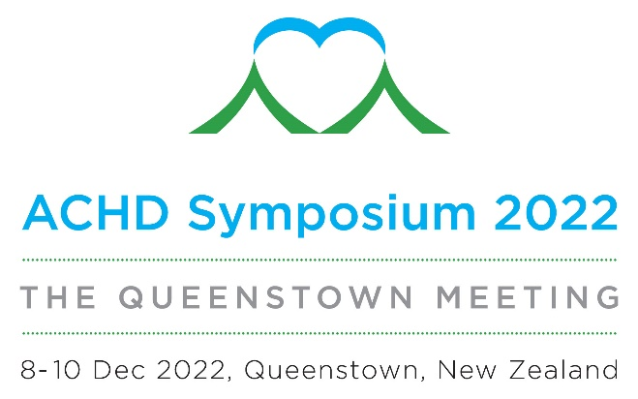

Fellows in training, Early career ACHD clinicians, Nursing and Allied Health Session Submission

To submit a proposal for a ten-minute presentation during this session please complete the form below and return to achd@theconferencecompany.com by Thursday 1 September 2022

Name
Professional Group
Institution
Presentation Title
Topic Description
(up to 100 words)

